THE SPRINGS MEDICAL PARTNERSHIP

NHS Family Doctor Services Registration

Please follow the instructions on the form as we will be unable to register you if the form is not fully completed.

If you require any help completing this form, please speak to a receptionist who will be happy to help you fill it in.
If you require a copy of this form in a different format, please speak to a receptionist who will be able to assist with this.

Please complete all sections 1-5.
We will not be able to complete your registration if the form is not fully completed.
Section 6 only complete if you do not normally live in the UK.

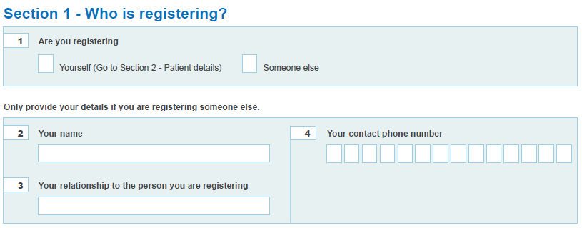
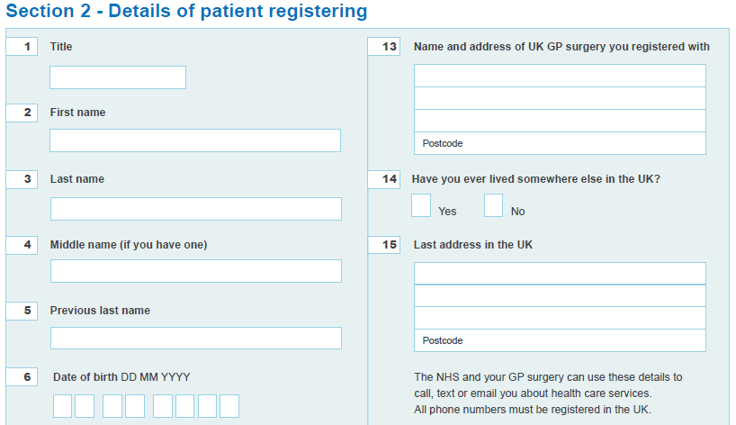

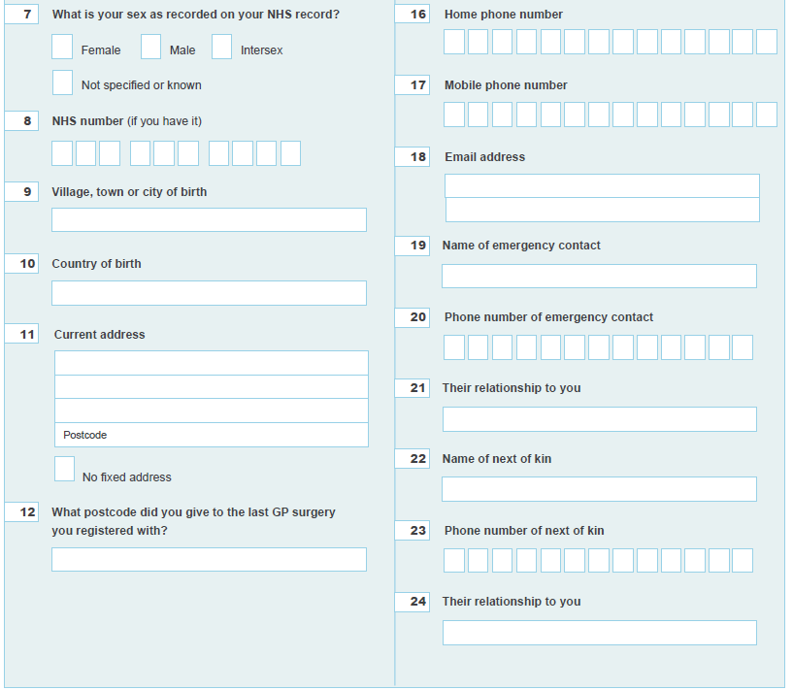
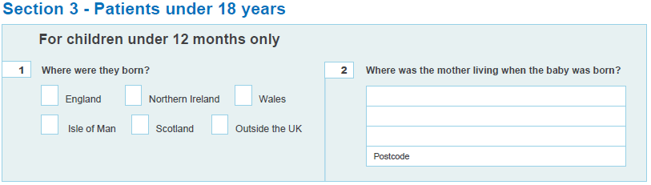

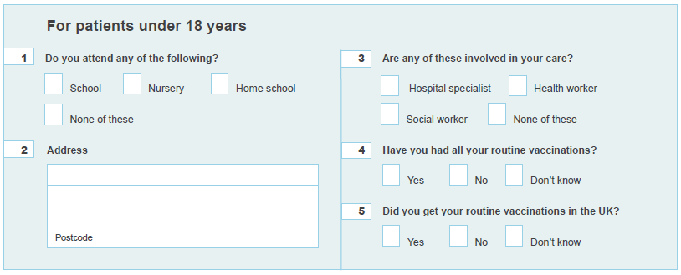
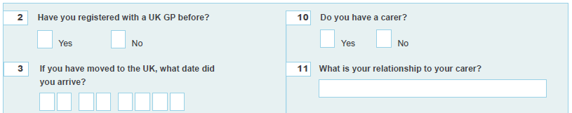
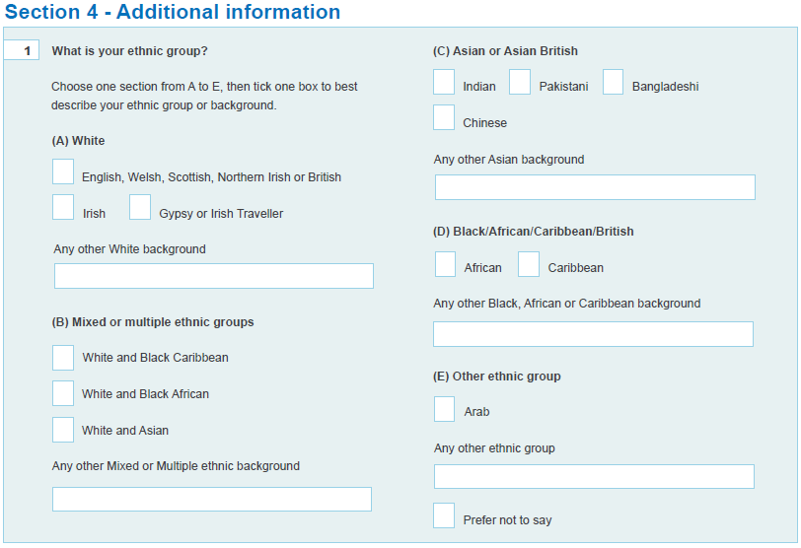

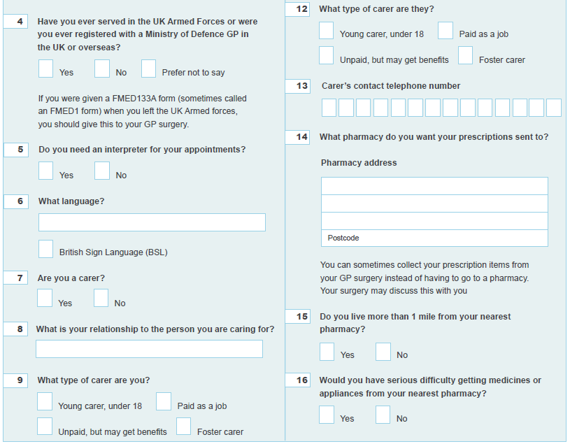
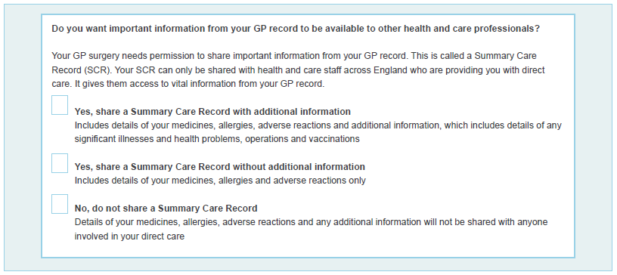

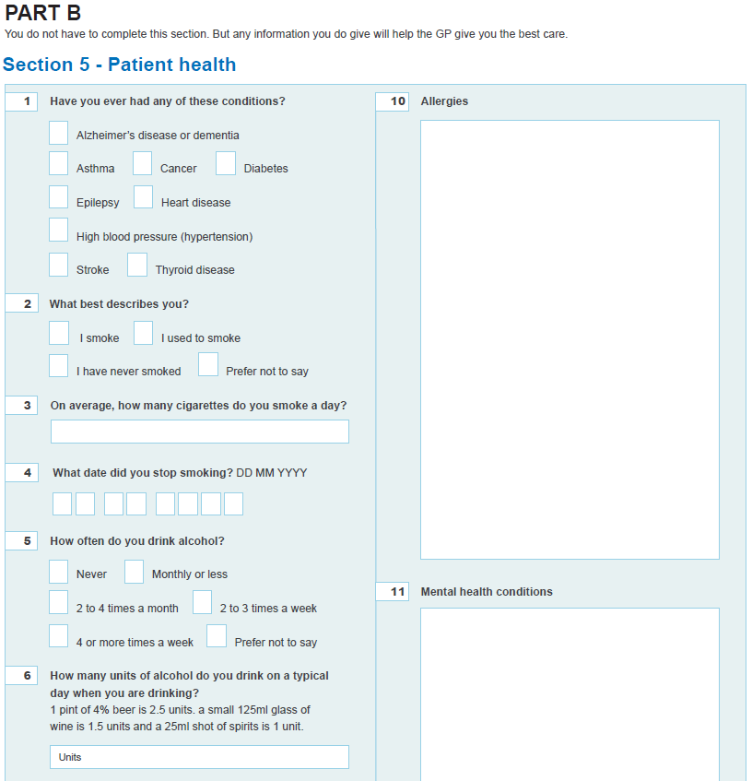
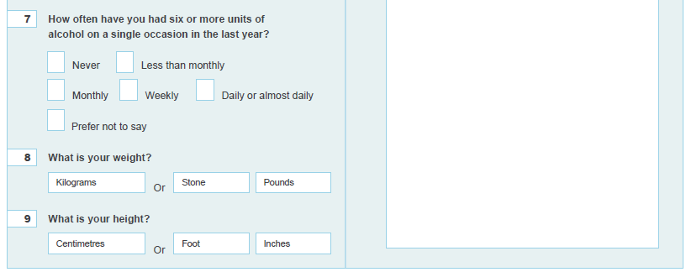

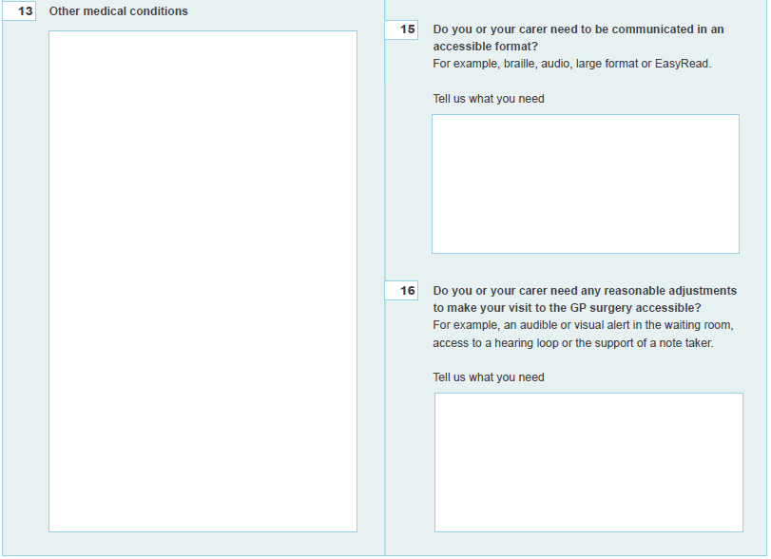
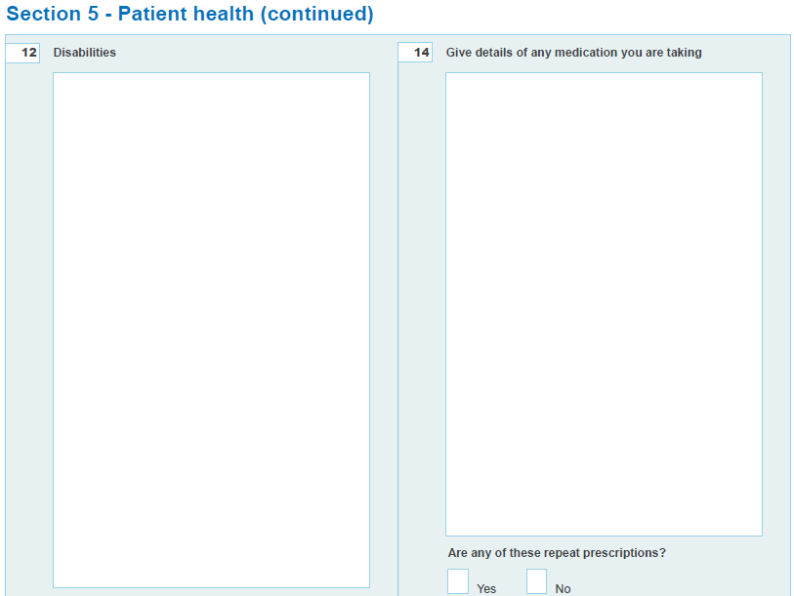

If you would like access to online services, please tick below. You will need to provide photo ID with your registration form for us to be able to activate this for you.

Medication requesting
Questionnaires
Summary record access
Full clinical record access

